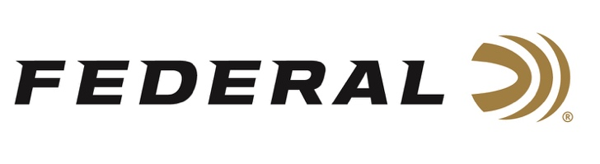
FOR IMMEDIATE RELEASE

Pandemic Delay Provides Extra Practice Time for USA Shooting Shotgun Teams

ANOKA, Minnesota – June 16, 2021 – As the 2021 Olympic Games approach, USA Shooting team members Kayle Browning, Brian Burrows, Vincent Hancock, Austen Smith, and Derrick Mein are intently focused on preparing to finally compete on the world stage after a year-long delay due to the COVID-19 pandemic. The postponement was a shock for all Olympic athletes, but from difficulty comes opportunity, and the team has made the most of the extra time by putting a whole lot of rounds through their shotguns during the past year’s delay.

“These athletes compete at the highest level, they are extremely accomplished and worked hard to compete for their country in front of the entire world,” stated Jason Vanderbrink, President of Federal Ammunition. “As a company that sponsors the USA Shooting team, we can’t wait to watch them compete, and for Federal Ammunition to be part of them accomplishing their goals of bringing home Olympic medals.”

“Preparing for Tokyo has been difficult to say, at the very least,” said Vincent Hancock, a skeet shooter who took gold medals in the 2008 and 2012 games. “After the delay and some time off, I’ve maintained my training at a high level for the past four to five months now, working diligently to make sure I reach my peak at just the right time and that I’m ready for the tests of competition.”

“I have been firing a lot of Federal Gold Medals to get ready for the Olympics. I fully expect to put forth my best effort at this year’s Olympic Games, and for me, that means eliminating mistakes,” said Derrick Mein, who took full advantage of the extra time he’s had to prepare and recently won the Super Sporting event at the NSCA’s U.S. Open last weekend while competing at Claythorne Lodge in Kansas. “The extra year has given me a great opportunity to fine tune my game.”

“It has been a very unique situation. At first, I was really bummed out, like a lot of other athletes,” Kayle Browning said. “But once the shock of the games getting postponed wore off, I quickly realized I’d been given a great training opportunity. I began taking full advantage of the training facility that’s literally in my back yard.”

“I’m ecstatic for the Olympic Games this July! This will be the first games I will compete in, and it will be the completion of four years of intense training and sacrifices,” said Austen Smith. “The delay was heartbreaking at first, but I found a way to convert that heartbreak into determination. Throughout the lockdowns and competition cancellations I dedicated myself to training in any way possible.”

Brian Burrows said the delay definitely changed how he expected to prepare for the games.

“Typically, we would have shot three or four World Cups plus a test event on the Olympic range, but this time we had one world cup and no test event. So, I have had to adapt and adjust how I prepare for the Olympics, but I am confident in my training, and it has paid off,” Burrows said. “In the one world cup we shot, I entered the final in second place with a very strong qualification score. So, even though I had to adapt my training to the delay, I feel very confident.”

Federal is the official shotshell ammunition sponsor and supplier of USA Shooting, a non-profit organization that promotes the shooting sports and prepares American athletes to bring home Olympic gold. Learn more at: www.usashooting.org.

Federal Ammunition can be found at dealers nationwide or purchased online direct from Federal. For more information on all products from Federal or to shop online, visit www.federalpremium.com.

Press Release Contact: JJ Reich
Senior Manager – Press Relations
E-mail: VistaPressroom@VistaOutdoor.com

About Federal Ammunition
Federal, headquartered in Anoka, MN, is a brand of Vista Outdoor Inc., an outdoor sports and recreation company. From humble beginnings nestled among the lakes and woods of Minnesota, Federal Ammunition has evolved into one of the world's largest producers of sporting ammunition. Beginning in 1922, founding president, Charles L. Horn, paved the way for our success. Today, Federal carries on Horn's vision for quality products and service with the next generation of outdoorsmen and women. We maintain our position as experts in the science of ammunition production. Every day we manufacture products to enhance our customers' shooting experience while partnering with the conservation organizations that protect and support our outdoor heritage. We offer thousands of options in our Federal Premium and Federal® lines-it's what makes us the most complete ammunition company in the business and provides our customers with a choice no matter their pursuit.

